CS 461

Lab Assignment 8

Name: Gandhi Dhruv Vipulkumar

Institute ID: 202151053

Date: 22-10-2024

**NOTE**: Due to unavailability of NVIDIA GPU in the local machine the following code is run on google colab.

Link: <https://colab.research.google.com/drive/1ztJ8tsSUh5BT5raDCKg8Tmfa3-HYcn_m?usp=sharing>

**Q. Implement Matrix Multiplication using CUDA**

!apt-get install nvidia-cuda-toolkit g++

%%writefile matrix_mul.cu  
#include <stdio.h>  
#include <stdlib.h>  
#include <assert.h>  
#include <cuda_runtime.h>  
#include <omp.h>  
  
#define BLOCK_SIZE 16  
#define PRINT_LIMIT 10 // Limit to print elements of large matrices  
  
// Function to print a matrix (with limits for large matrices)  
void print_matrix(int* matrix, int rows, int cols, const char* name)   
{  
    printf("Matrix %s (%d x %d):\n", name, rows, cols);  
    for (int i = 0; i < rows && i < PRINT_LIMIT; ++i)   
    {  
        for (int j = 0; j < cols && j < PRINT_LIMIT; ++j)   
        {  
            printf("%4d ", matrix[i * cols + j]);  
        }  
        if (cols > PRINT_LIMIT)   
        {  
            printf("... "); // Print ellipsis if there are more columns  
        }  
        printf("\n");  
    }  
    if (rows > PRINT_LIMIT)   
    {  
        printf("... \n"); // Print ellipsis if there are more rows  
    }  
    printf("\n");  
}  
  
// CUDA kernel for general matrix multiplication  
__global__ void gpu_matrix_mult(int* a, int* b, int* c, int m, int n, int k)   
{  
    int row = blockIdx.y * blockDim.y + threadIdx.y;  
    int col = blockIdx.x * blockDim.x + threadIdx.x;  
    int sum = 0;  
    if (col < k && row < m)   
    {  
        for (int i = 0; i < n; i++)   
        {  
            sum += a[row * n + i] * b[i * k + col];  
        }  
        c[row * k + col] = sum;  
    }  
}  
  
// CUDA kernel for square matrix multiplication  
__global__ void gpu_square_matrix_mult(int* d_a, int* d_b, int* d_result, int n)   
{  
    __shared__ int tile_a[BLOCK_SIZE][BLOCK_SIZE];  
    __shared__ int tile_b[BLOCK_SIZE][BLOCK_SIZE];  
  
    int row = blockIdx.y * BLOCK_SIZE + threadIdx.y;  
    int col = blockIdx.x * BLOCK_SIZE + threadIdx.x;  
    int tmp = 0;  
    int idx;  
  
    for (int sub = 0; sub < gridDim.x; ++sub)   
    {  
        idx = row * n + sub * BLOCK_SIZE + threadIdx.x;  
        tile_a[threadIdx.y][threadIdx.x] = (idx < n * n) ? d_a[idx] : 0;  
  
        idx = (sub * BLOCK_SIZE + threadIdx.y) * n + col;  
        tile_b[threadIdx.y][threadIdx.x] = (idx < n * n) ? d_b[idx] : 0;  
  
        __syncthreads();  
  
        for (int k = 0; k < BLOCK_SIZE; ++k)   
        {  
            tmp += tile_a[threadIdx.y][k] * tile_b[k][threadIdx.x];  
        }  
        __syncthreads();  
    }  
  
    if (row < n && col < n)   
    {  
        d_result[row * n + col] = tmp;  
    }  
}  
  
// OpenMP function for matrix multiplication (parallelized)  
void openmp_matrix_mult(int* h_a, int* h_b, int* h_c, int m, int n, int k)   
{  
#pragma omp parallel for collapse(2)  
    for (int i = 0; i < m; ++i)   
    {  
        for (int j = 0; j < k; ++j)   
        {  
            int tmp = 0;  
            for (int h = 0; h < n; ++h)   
            {  
                tmp += h_a[i * n + h] * h_b[h * k + j];  
            }  
            h_c[i * k + j] = tmp;  
        }  
    }  
}  
  
// Normal (sequential) matrix multiplication function  
void cpu_matrix_mult(int* h_a, int* h_b, int* h_result, int m, int n, int k)   
{  
    for (int i = 0; i < m; ++i)   
    {  
        for (int j = 0; j < k; ++j)   
        {  
            int tmp = 0;  
            for (int h = 0; h < n; ++h)   
            {  
                tmp += h_a[i * n + h] * h_b[h * k + j];  
            }  
            h_result[i * k + j] = tmp;  
        }  
    }  
}  
  
// Main function  
int main(int argc, char const* argv[])   
{  
    int m, n, k;  
    srand(3333); // Fixed seed  
    printf("Please type in m, n, and k: ");  
    scanf("%d %d %d", &m, &n, &k);  
  
    // Allocate memory in host RAM  
    int* h_a, * h_b, * h_c, * h_cc;  
    cudaMallocHost((void**)&h_a, sizeof(int) * m * n);  
    cudaMallocHost((void**)&h_b, sizeof(int) * n * k);  
    cudaMallocHost((void**)&h_c, sizeof(int) * m * k);  
    cudaMallocHost((void**)&h_cc, sizeof(int) * m * k);  
  
    // Random initialize matrix A  
    for (int i = 0; i < m; ++i)   
    {  
        for (int j = 0; j < n; ++j)   
        {  
            h_a[i * n + j] = rand() % 1024;  
        }  
    }  
  
    // Random initialize matrix B  
    for (int i = 0; i < n; ++i)   
    {  
        for (int j = 0; j < k; ++j)   
        {  
            h_b[i * k + j] = rand() % 1024;  
        }  
    }  
  
    // Print matrices A and B  
    print_matrix(h_a, m, n, "A");  
    print_matrix(h_b, n, k, "B");  
  
    float gpu_elapsed_time_ms, cpu_elapsed_time_ms, normal_elapsed_time_ms;  
  
    // Start measuring GPU execution time  
    cudaEvent_t start, stop;  
    cudaEventCreate(&start);  
    cudaEventCreate(&stop);  
    cudaEventRecord(start, 0);  
  
    // Allocate memory space on the device   
    int* d_a, * d_b, * d_c;  
    cudaMalloc((void**)&d_a, sizeof(int) * m * n);  
    cudaMalloc((void**)&d_b, sizeof(int) * n * k);  
    cudaMalloc((void**)&d_c, sizeof(int) * m * k);  
  
    // Copy matrix A and B from host to device memory  
    cudaMemcpy(d_a, h_a, sizeof(int) * m * n, cudaMemcpyHostToDevice);  
    cudaMemcpy(d_b, h_b, sizeof(int) * n * k, cudaMemcpyHostToDevice);  
  
    unsigned int grid_rows = (m + BLOCK_SIZE - 1) / BLOCK_SIZE;  
    unsigned int grid_cols = (k + BLOCK_SIZE - 1) / BLOCK_SIZE;  
    dim3 dimGrid(grid_cols, grid_rows);  
    dim3 dimBlock(BLOCK_SIZE, BLOCK_SIZE);  
  
    // Launch the appropriate kernel  
    if (m == n && n == k)   
    {  
        gpu_square_matrix_mult << <dimGrid, dimBlock >> > (d_a, d_b, d_c, n);  
    }  
    else   
    {  
        gpu_matrix_mult << <dimGrid, dimBlock >> > (d_a, d_b, d_c, m, n, k);  
    }  
  
    // Transfer results from device to host   
    cudaMemcpy(h_c, d_c, sizeof(int) * m * k, cudaMemcpyDeviceToHost);  
    cudaDeviceSynchronize(); // Wait for GPU to finish  
    cudaEventRecord(stop, 0);  
    cudaEventSynchronize(stop);  
  
    // Compute time elapsed on GPU computing  
    cudaEventElapsedTime(&gpu_elapsed_time_ms, start, stop);  
    printf("Time elapsed on matrix multiplication of %dx%d . %dx%d on GPU: %f ms.\n", m, n, n, k, gpu_elapsed_time_ms);  
  
    // Print result matrix C (GPU result)  
    print_matrix(h_c, m, k, "C (GPU Result)");  
  
    // Start measuring normal (sequential) execution time  
    double start_time = omp_get_wtime();  
    cpu_matrix_mult(h_a, h_b, h_cc, m, n, k);  
    double end_time = omp_get_wtime();  
    normal_elapsed_time_ms = (end_time - start_time) * 1000.0; // Convert to milliseconds  
    printf("Time elapsed on normal matrix multiplication of %dx%d . %dx%d on CPU: %f ms.\n", m, n, n, k, normal_elapsed_time_ms);  
  
    // Print result matrix C (CPU result)  
    print_matrix(h_cc, m, k, "C (CPU Result)");  
  
    // Start measuring CPU execution time using OpenMP  
    start_time = omp_get_wtime();  
    openmp_matrix_mult(h_a, h_b, h_cc, m, n, k);  
    end_time = omp_get_wtime();  
    cpu_elapsed_time_ms = (end_time - start_time) * 1000.0; // Convert to milliseconds  
    printf("Time elapsed on matrix multiplication of %dx%d . %dx%d on CPU (OpenMP): %f ms.\n", m, n, n, k, cpu_elapsed_time_ms);  
  
    // Compare the results  
    int all_ok = 1;  
    for (int i = 0; i < m; i++)   
    {  
        for (int j = 0; j < k; j++)   
        {  
            if (h_cc[i * k + j] != h_c[i * k + j])   
            {  
                all_ok = 0;  
                printf("Mismatch at [%d][%d]: GPU=%d, CPU=%d\n", i, j, h_c[i * k + j], h_cc[i * k + j]);  
                break;  
            }  
        }  
        if (!all_ok) break;  
    }  
  
    printf("Matrix multiplication %s\n", all_ok ? "successful!" : "failed.");  
  
    // Free GPU memory  
    cudaFree(d_a);  
    cudaFree(d_b);  
    cudaFree(d_c);  
  
    // Free CPU memory  
    cudaFreeHost(h_a);  
    cudaFreeHost(h_b);  
    cudaFreeHost(h_c);  
    cudaFreeHost(h_cc);  
  
    return 0;  
}

**Code Explanation:**

**1.** **Includes and Defines**:

* Includes standard libraries for input/output, memory management, and CUDA runtime.
* Defines BLOCK_SIZE, which sets the dimensions of the blocks used in the CUDA kernel.

**2.** **CUDA Kernels**:

* **gpu_matrix_mult**: A kernel for general matrix multiplication. It computes the value for each element of the result matrix C based on matrices A and B.
* **gpu_square_matrix_mult**: An optimized kernel for square matrices that uses shared memory for better performance. It loads sub-matrices (tiles) into shared memory, reducing global memory accesses.

**3.** **Matrix Multiplication Functions**:

* **openmp_matrix_mult**: Uses OpenMP for parallel matrix multiplication on the CPU. It employs nested loops with #pragma omp parallel for collapse(2) to parallelize both outer loops.
* **cpu_matrix_mult**: A normal sequential implementation for matrix multiplication on the CPU.

**4.** **Main Function**:

* Reads the dimensions of the matrices from the user.
* Allocates memory for matrices A, B, and results C on both host (CPU) and device (GPU).
* Initializes matrices A and B with random values.
* Measures and prints the time taken for matrix multiplication on the GPU and CPU.
* Compares the results from GPU and CPU computations for correctness.
* Frees the allocated memory.

**Key Features:**

1. **CUDA Implementation**:

* The code utilizes CUDA for GPU acceleration, enabling efficient handling of matrix multiplication tasks, especially for larger matrices.

2. **Optimized Memory Usage**:

* Uses shared memory in the gpu_square_matrix_mult kernel to speed up memory access times by reducing global memory accesses.

3. **Parallelization**:

* The code showcases different levels of parallelization: GPU-based with CUDA and CPU-based using OpenMP.

4. **Performance Measurement**:

* It measures the execution time for GPU and CPU matrix multiplication, allowing for performance comparisons.

5. **Validation**:

* The code checks the results of the matrix multiplication between GPU and CPU to ensure correctness, printing mismatches if found.

6. **Dynamic Input**:

* The dimensions of the matrices are provided by the user at runtime, making the program flexible for different sizes of matrices.

7. **User-Friendly Output**:

* It prints the matrices before multiplication and shows the resulting matrices for both GPU and CPU, making it easy to verify results.

**Testing Phase:**

**1) multiplication for very small matrices(3x3):**

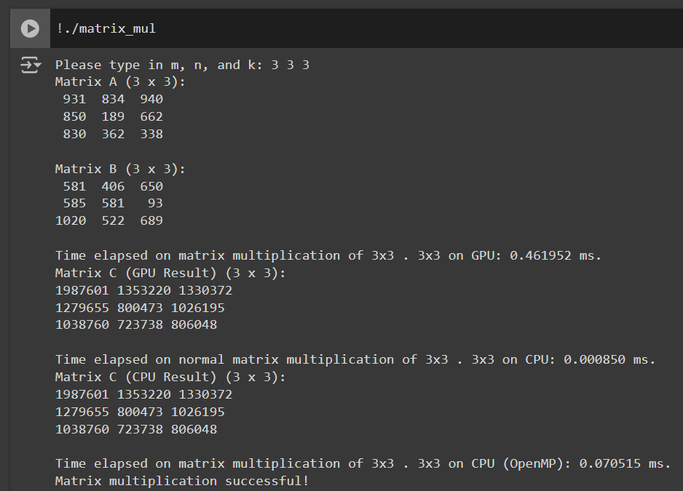

* Time elapsed on matrix multiplication of 3x3 . 3x3 on GPU**: 0.461952 ms.**
* Time elapsed on normal matrix multiplication of 3x3 . 3x3 on CPU: **0.000850 ms.**
* Time elapsed on matrix multiplication of 3x3 . 3x3 on CPU (OpenMP): **0.070515 ms.**

**2) Multiplication for small matrices(10x10):**

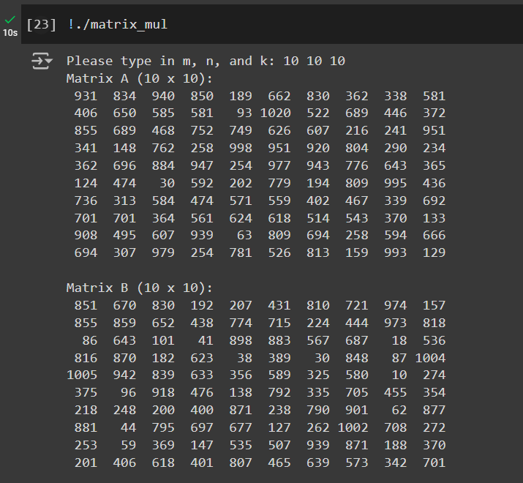

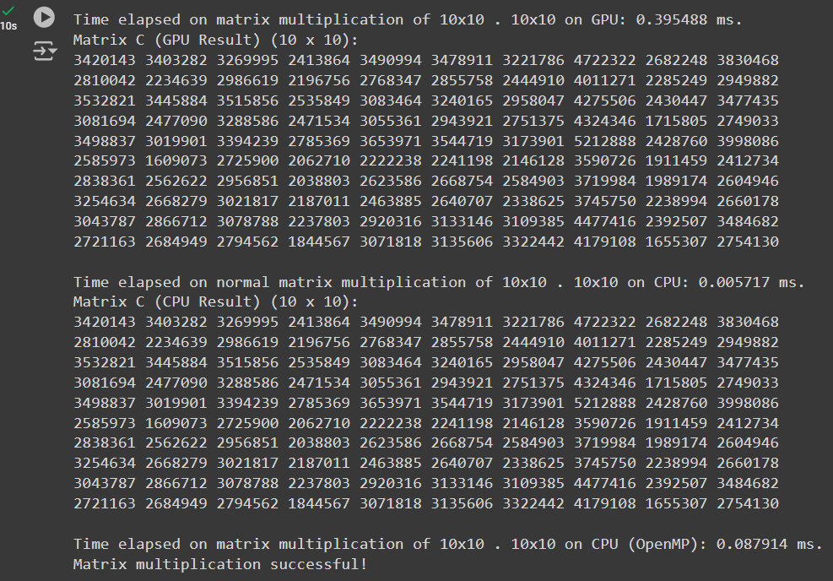

* Time elapsed on matrix multiplication of 10x10 . 10x10 on GPU: **0.395488 ms.**
* Time elapsed on normal matrix multiplication of 10x10 . 10x10 on CPU: **0.005717 ms.**
* Time elapsed on matrix multiplication of 10x10 . 10x10 on CPU (OpenMP): **0.087914 ms.**

**3) Increase the size of matrices(100x100):**

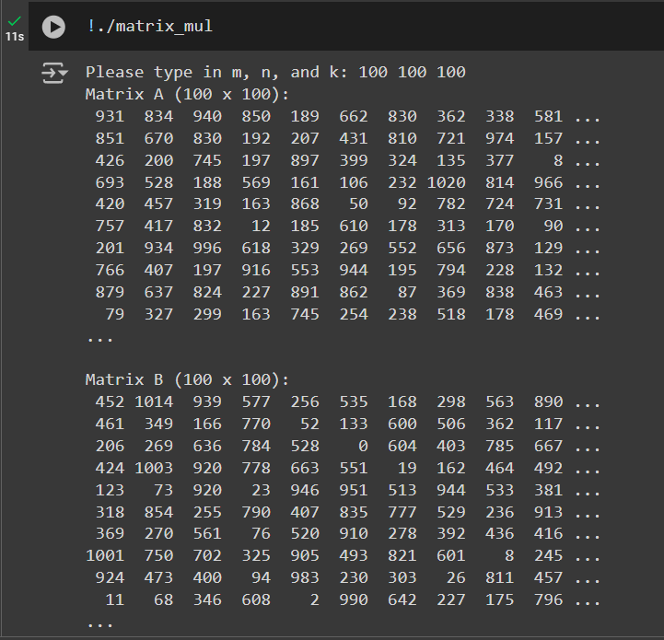

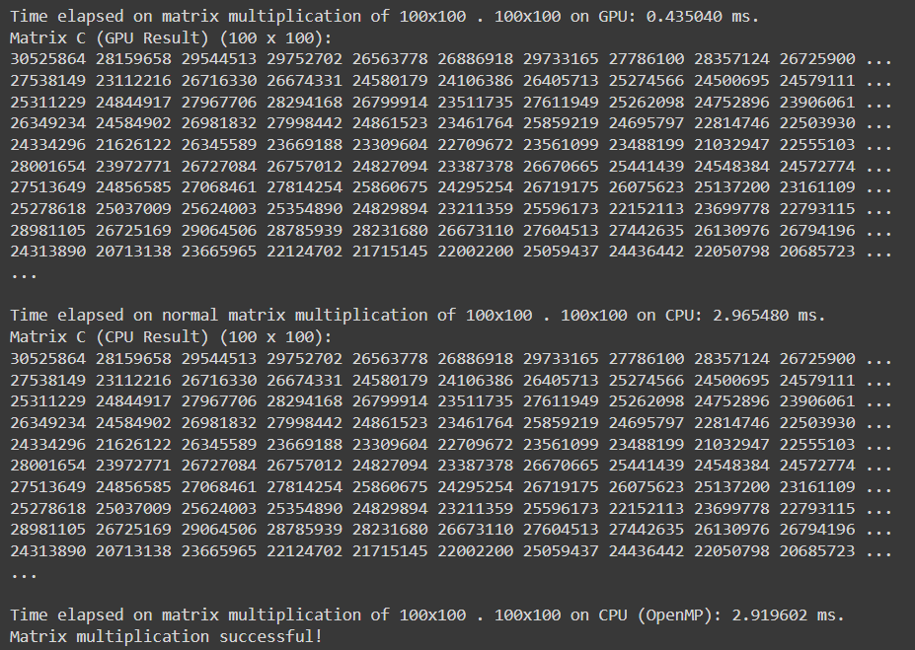

* Time elapsed on matrix multiplication of 100x100 . 100x100 on GPU: **0.435040 ms.**
* Time elapsed on normal matrix multiplication of 100x100 . 100x100 on CPU: **2.965480 ms.**
* Time elapsed on matrix multiplication of 100x100 . 100x100 on CPU (OpenMP): **2.919602 ms.**

**4) Matrix multiplication for large matrices(1000x1000):**

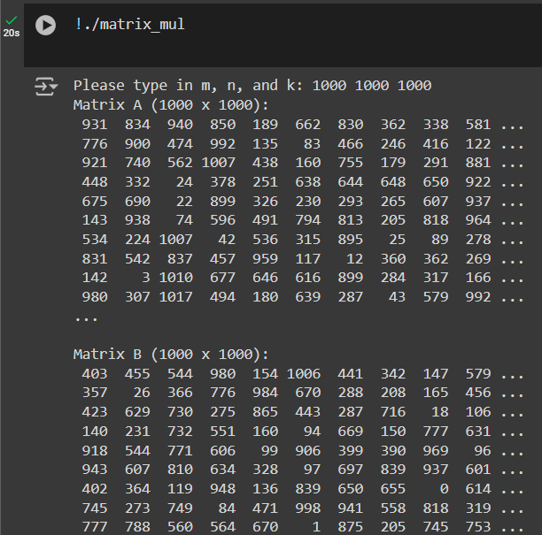

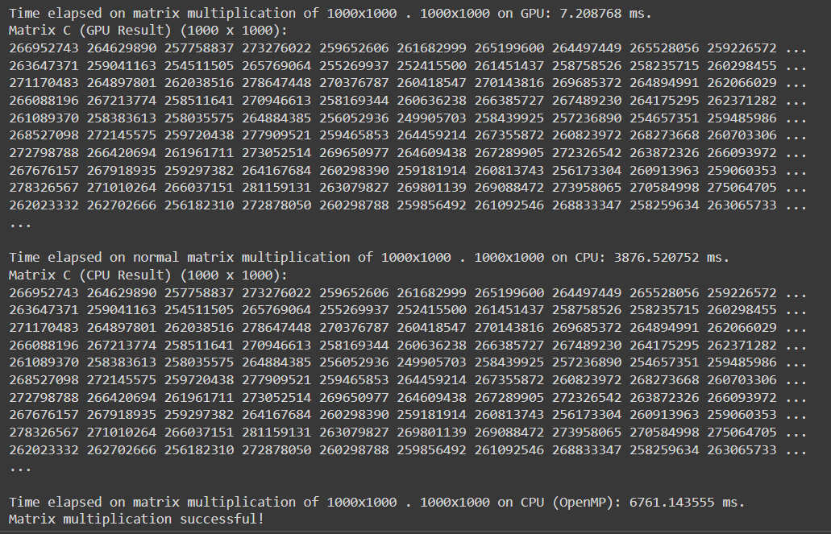

* Time elapsed on matrix multiplication of 1000x1000 . 1000x1000 on GPU: **7.208768 ms.**
* Time elapsed on normal matrix multiplication of 1000x1000 . 1000x1000 on CPU: **3876.520752 ms.**
* Time elapsed on matrix multiplication of 1000x1000 . 1000x1000 on CPU (OpenMP): **6761.143555 ms.**

**5) Matrix Multiplication for very large matrices(5000x5000):**

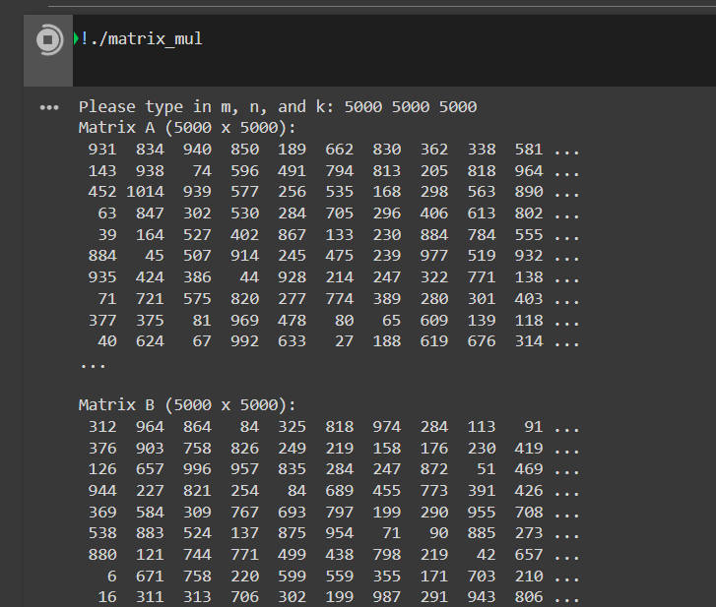

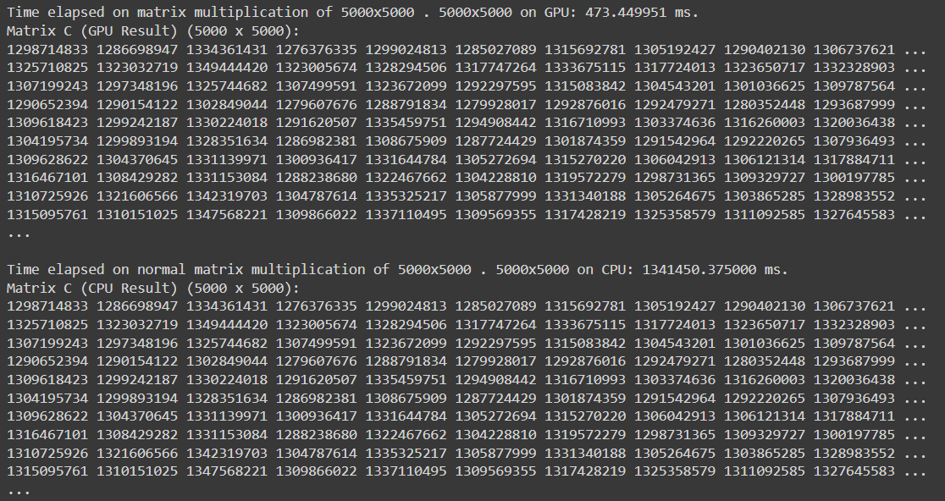

* Time elapsed on matrix multiplication of 5000x5000 . 5000x5000 on GPU: **473.449951 ms.**
* Time elapsed on normal matrix multiplication of 5000x5000 . 5000x5000 on CPU: **1341450.375000 ms.**

**Conclusion:** Successfully computed Matrix Multiplication using CUDA and we can clearly observe that for large matrices, the matrix multiplication on GPU is much faster than CPU.